CHAPTER 4. FACILITY REQUIREMENTS
Introduction
Facility cility requirements chapter is to determine whether existing airport infrastructure is sufficient to accommodate current usage and future growth using FAA standards and guidelines. As an analysis of the Airport’s capabilities, facility requirements are the result of the inventory and forecasts chapters as well as area planning, research, and analysis. They explain the relevancy of existing airport facilities and determine what facilities may be necessary in the future. Facility needs are based upon forecasted use and evaluation procedures include the analysis of runway length, dimensions of aprons and hangars, and vehicle access.
Although this analysis uses the forecasts presented in the preceding chapter for establishing future development at Lopez Island Airport, it is not intended to dismiss the possibility that either accelerated growth or consistently higher or lower levels of activity may occur. Additionally, as described in the previous chapter, an airport’s geometric design is based on the specified Runway Design Code (RDC) standards as specified in FAA AC 150/5300-13A. Although the RDC is based on the “Critical Aircraft” or “Design Aircraft” and is used for planning and design, it does not limit the aircraft that may be able to operate safely at an airport. In addition to the aircraft approach speed and wingspan components comprising the RDC introduced in the previous chapter, a third component is also present and it is related to the lowest instrument approach visibility minimums. The instrument approach visibility minimums are expressed as Runway Visual Range (RVR) values in feet. Table 4-1 provides the instrument approach visibility minimums and corresponding RVR value. Lopez Island Airport has visual approaches only, so the full RDC for it is expressed as B-I-VIS (Small Aircraft). The B is based on the aircraft approach speed, or 1.3 times the aircraft stall speed, in this case “B” is between 91 to 120 knots. The “I” designation is the critical aircraft wingspan, which is less than 49 feet. The Lopez Island Critical Aircraft Design Group as determined in the Forecast chapter is B-I (Small Aircraft), with the small referring to aircraft having certificated maximum takeoff weight less than 12,500 pounds. The “VIS” stands for Visual because there are no instrument approaches and no Runway Visual Range equipment at the airport.

Lopez Island Airport 4-1
Master Plan Update
December 2018

Table 4-1. RVR Values
Instrument Flight Visibility Category (statute mile) | RVR (feet)¹
Visual | VIS
Not lower than 1 mile | 5000
Lower than 1 mile but not lower than ³/₄ mile | 4000
Lower than ³/₄ mile but not lower than ¹/₂ mile  Lower than ¹/₂ mile but no t | 2400
Lower than ¹/₂ mile not lower than ¹/₄ mile | 1600
Lower than ¹/₄ mile | 1200
Source: FAA AC 150/5300-13A, Change 1, Airport Design.
Note: ¹RVR values are not exact equivalents.
Facilities at Lopez Island Airport can be divided into two general categories: airside and landside. Airside facilities are those that are related directly with the movement of aircraft (i.e., runway, taxiways, approach areas, lighting systems, and navigational aids). Landside facilities encompass terminal buildings, hangars, aircraft aprons, surface access, automotive parking, etc. The components of landside and airside are determined based upon standards set by the FAA.
Airside Facility Requirements
The airside facility requirements analysis focuses on determining the necessary elements and the spatial relationship of the elements. The evaluation includes the delineation of airfield dimensional criteria, establishment of design parameters for the runway and taxiway systems, runway length and an identification of airfield instrumentation and lighting needs.
Wind Analysis
Climatological conditions specific to the location of an airport not only influence the layout of the airfield, but also affect the use of the runway system. Variations in the weather resulting in limited cloud ceilings and reduced visibility typically restrict the time an airport is available for use by aircraft, while changes in wind direction and velocity typically dictate runway usage. When landing and taking off, aircraft are able to operate on a runway properly and safely as long as the wind velocity perpendicular to the direction of travel (i.e., a crosswind) is not excessive. Wind conditions affect all aircraft to some extent, but the smaller the aircraft, generally the more it is affected by crosswinds. The wind coverage analysis translates the crosswind velocity and direction into a “crosswind component”.
The appropriate crosswind component is dependent upon the RDC for the type of aircraft that utilize an airport on a regular basis. As previously identified, the RDC for Lopez Island Airport is B-I-VIS (Small Aircraft). According to the FAA AC 150/5300-13A, a crosswind component of 10.5 knots is considered maximum for runways with a RDC designation of A-I and B-I. Therefore, for Runway 16/34, a crosswind component of 10.5 knots will be utilized to analyze the adequacy of the runway orientation with the prevailing wind conditions.
Lopez Island Airport 4-2
Master Plan Update
December 2018

To determine wind velocity and direction at Lopez Island Airport, accurate and timely wind data was obtained for the period between January 1, 2006 and December 31, 2015 for Friday Harbor Airport, as wind data for Lopez Island Airport is not available. The data was compiled by the National Oceanic and Atmospheric Administration, National Climatic Data Center. Using this data, an all-weather wind rose was constructed and is presented in Exhibit 4-1.
Exhibit 4-1. All Weather Wind Rose
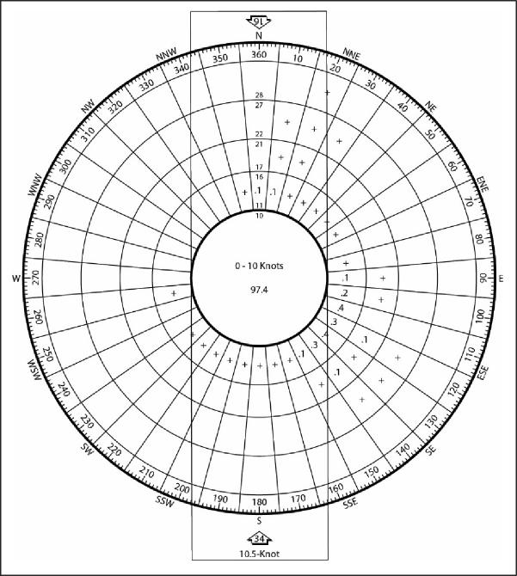
Table 4-2 quantifies the wind coverage provided by the individual runway ends and Runway 16/34 during all weather conditions at the Airport. The desirable wind coverage for a runway is 95 percent, which means that the runway should be oriented so that the maximum crosswind component is not exceeded more than 5 percent of the time. Runway 16/34 provides 95.69% percent wind coverage for 10.5-knot crosswind component, which indicates that the existing runway configuration provides adequate wind coverage for the 10.5-knot crosswind component. A five-knot tailwind component is used in the individual runway end analysis because aircraft can operate with a slight tailwind, so a realistic wind analysis assumes some level of use for each runway end with a tailwind.
Lopez Island Airport 4-3
Master Plan Update
December 2018

Table 4-2. All Weather Wind Coverage Analysis
▪ Runway Designation | 10.5-Knot  Crosswind Component
Runway 16¹ | 90.29%
Runway 34¹ | 84.14%
Runway 16/34 | 95.69%
Source: Wind analysis tabulation provided by Reid Middleton, Inc. and Mead & Hunt utilizing the FAA Airport Design Tools, Wind Analysis. Wind data obtained from the National Oceanic and Atmospheric Administration, National Climate Data Center. Station 727985 Friday Harbor Airport. Period of Record: 2006-2015.
Note: A 5-knot tailwind component was used for the individual runway end analysis.
Airport Design Standards
The airport design standards applicable to Lopez Island Airport are presented in Table 4-3. Airport design standards are based on the appropriate RDC and are contained in Advisory Circular (AC) 150/5300-13A, Change 1. The design standards have been developed to assure that facilities can be operated in a safe and efficient manner and represent a minimum standard to be achieved. As presented, Lopez Island Airport meets or exceeds all the FAA airport design standards associated with RDC B-I-VIS (Small Aircraft), with two exceptions associated with the Runway Safety Area (RSA) at each runway end. The RSA is a defined surface centered on the runway centerline, prepared and suitable for reducing the risk of damage to aircraft in the event of an undershoot, overshoot, or excursion from the runway. It must be cleared and graded and have no potentially hazardous ruts, humps, depressions, or other surface variations; drained by grading or storm sewers to prevent water accumulation; capable under dry conditions of supporting rescue vehicles; and free of objects except those that must be located in the RSA by function (i.e., runway edge lights). If objects higher than three inches must be located within the RSA, then to the extent practical, they must be constructed on frangible mounted structures of the lowest practical height with the frangible point no higher than three inches above grade. The standard maximum RSA gradient within 200 feet of a runway end is 3.0%, with a maximum allowable gradient of 5.0% beyond that.
The existing grade at the northwest corner of the Runway 16 RSA is nearly 8.5%; the existing grade at the southeast corner of the Runway 34 RSA is nearly 9.0%. Exhibit 4-3 graphically presents the grade deficiencies associated with the RSA. It should be noted that the Port of Lopez has programmed a Fiscal Year 2018 project to extend the Runway 16 RSA to the full 240-foot length required.
Lopez Island Airport 4-4
Master Plan Update
December 2018

Table 4-3. Runway 16/34 Airport Design Standards
Item | Existing  Dimension | B-I-VIS¹
Runway Width | 60’ | 60’
Runway Safety Area
Width | 120’ | 120’
Length Beyond Runway End:
Runway 16 | 200’ | 240’
Runway 34 | 200’ | 240’
Length Prior to Landing Threshold
Runway 16 | 240’ | 240’
Runway 34 | 240’ | 240’
Runway Object Free Area
Width | 250’ | 250’
Length Beyond Runway End
Runway 16 | 240’ | 240’
Runway 34 | 240’ | 240’
Runway Obstacle Free Zone
Width | 250’ | 250’
Length
Runway 16 | 200’ | 200’
Runway 34 | 200’ | 200’
Runway Centerline To:
Parallel Taxiway | 150’ | 150’
Aircraft Parking | 190’ | 125’
Holding Position Line | 125’ | 125’
Source: FAA AC 150/5300-13A, Change 1, Airport Design.
Note: ¹Airport Design Standards for small aircraft (i.e., aircraft with maximum takeoff weights less than 12,500 pounds).

Lopez Island Airport 4-5
Master Plan Update
December 2018

Exhibit 4-2. Runway 16/34 RSA Non-Standard Conditions
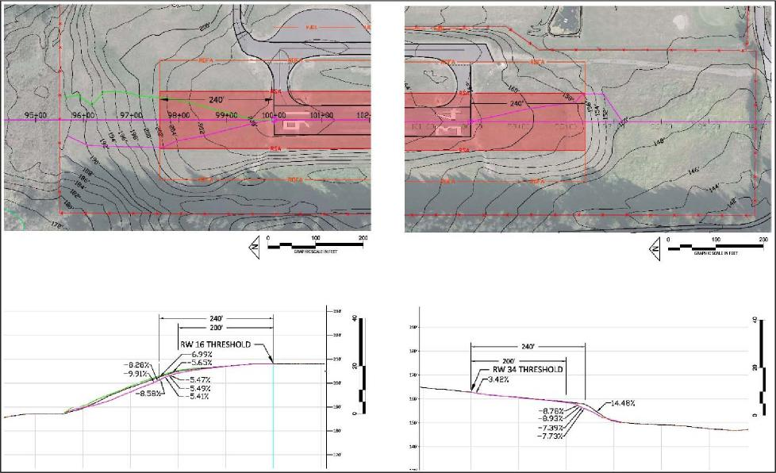
Runway Length Analysis
Generally, for runway design purposes, the determination of appropriate runway length
recommendations at general aviation airports is premised upon a combination of factors, which include:
- Airport Elevation
- Mean maximum daily temperature of the hottest month
- Runway gradient
- Family grouping of critical aircraft for runway length purpose
The runway length operational requirements for aircraft are greatly affected by elevation, temperature, and runway gradient. The calculation for runway length requirement at Lopez Island Airport is based on an elevation of 205.2 feet Above Mean Sea Level (AMSL), 68° Fahrenheit Mean Normal Maximum Temperature (MNMT) of the hottest month, and a maximum difference in runway elevation at the centerline of 46 feet.
Runway length determination involves the family grouping of critical aircraft consisting of those aircraft types deemed the most demanding aircraft within the general aviation fleet that are
Lopez Island Airport 4-6
Master Plan Update
December 2018

operating or are projected to operate at the airport. For Lopez Island Airport, this fleet is dominated by small aircraft with maximum takeoff weight of less than 12,500 pounds and having fewer than ten passenger seats, as provided in Table 4-4.
Table 4-4. Critical Design Aircraft for Runway Length
Aircraft | RDC | Maximum  Takeoff  Weight  (MTOW) -  pounds | Number of Seats | Estimated  2015  Operations | Runway  Length (in  feet)
Beech Super King Air 200 | B-II | 12,500 | 6 | 40 | 2,845¹
Cessna 206 | B-I | 3,600 | 6 | 400 | 1,860
Piper Malibu Meridian | B-I | 5,092 | 6 | 180 | 2,335
Piper Cheyenne 2 | B-I | 9,000 | 6 | 20 | 1,980
Pilatus PC-12 | B-II | 10,500 | 9 | 26 | 2,230
Beech Bonanza 33 | A-I | 3,650 | 6 | 600 | 1,769
Piper Cherokee | A-I | 2,150 | 4 | 500 | 1,759
Source: Aircraft Ground Service Guide, National Air Transportation Association (NATA), 2002.
Note: ¹Landing distance.
According to FAA AC 150/5325-4B, Runway Length Requirements for Airport Design, there are two runway length recommendations for aircraft with less than ten passenger seats based a percentage of the small aircraft fleet, as presented in Table 4-5. Exhibit 4-3 presents the runway length curves provided in AC 150/5325-4B used for calculating the runway length required of aircraft with fewer than ten passenger seats operating at Lopez Island Airport with a mean daily maximum temperature of 68° Fahrenheit and an elevation of 205.2 feet (green arrows). The small aircraft fleet with less than ten passenger seats is further divided into two family groupings according to “percentage of the fleet”. According to AC 150/5325-4B, the primary difference between the two categories is the 95% category is intended to serve medium size population communities with a diversity of usage and a greater potential for increased aviation activities. It also includes those airports that are primarily intended to serve low-activity locations, small population communities, and remote recreational areas. The 100% category is primarily intended to serve communities located on the fringe of a metropolitan area or a relatively large population remote from a metropolitan area.
Table 4-5. Runway 16/34 Length Recommendations, In Feet
 | Runway Length
Existing Runway 16/34 Length | 2,904
Small Airplanes with Fewer than 10 Passenger Seats
95% of Fleet | 2,900
100% of Fleet | 3,450
Source: Reid Middleton, Inc. and Mead & Hunt analysis utilizing FAA AC 150/5325-4B, Runway Length Requirements for Airport Design.
Lopez Island Airport 4-7
Master Plan Update
December 2018

Exhibit 4-3. Runway Length Curve
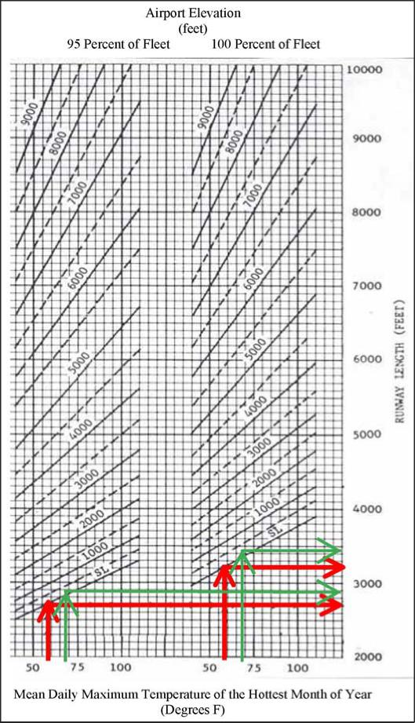
Source: FAA AC 150/5325-4B, Runway Length Requirements for Airport Design.
Because Lopez Island Airport is a low activity airport serving a small population community, the 95% family grouping of small aircraft with less than 10 passenger seats is the appropriate category. The existing runway length of 2,904 accommodates the recommended runway length of approximately 2,900 feet for this aircraft family grouping.
Lopez Island Airport 4-8
Master Plan Update
December 2018

Runway Protection Zones
The function of Runway Protection Zones (RPZ) is to enhance the protection of people and property on the ground beyond the runway ends. This is achieved through airport control of the RPZ areas, and control is preferably exercised through fee simple ownership by the airport within the RPZs. It is desirable to clear all above ground objects from within RPZs; where this is impractical, airport owners, at a minimum, should maintain the RPZ clear of all facilities supporting incompatible activities.
Table 4-6 presents the existing RPZ dimensions and the dimensional requirements for an airport designed to accommodate small aircraft only and having only visual approaches. As can be seen, the existing RPZs meet the dimensional standards associated with these criteria. However, the Runway 34 RPZ extends beyond airport property south of the airport, west and east of Shark Reef Road, into private property containing one residence, as illustrated in Exhibit 4-4. It is recommended that the Port of Lopez continue to program for property acquisition of the remainder of lands within the Runway 34 RPZ beyond airport property.
Table 4-6. Runway Protection Zone Dimensions, In Fee
Runway Protection Zone | Inner  Width | Length | ^{Outer}  Width | Airport  Controls Entire Land Area
Existing RPZ Dimensions
Runway 16 | 250 | 1,000 | 450 | Yes
Runway 34 | 250 | 1,000 | 450 | No
Standard Approach RPZ Dimensions Applicable to Lopez Island Airport
Visual and not lower than one statute mile, Small Aircraft Only | 250 | 1,000 | 450
Source: FAA AC 150/5300-13A, Change 1, Airport Design.

Lopez Island Airport 4-9
Master Plan Update
December 2018

Exhibit 4-4 Runway Protection Zones
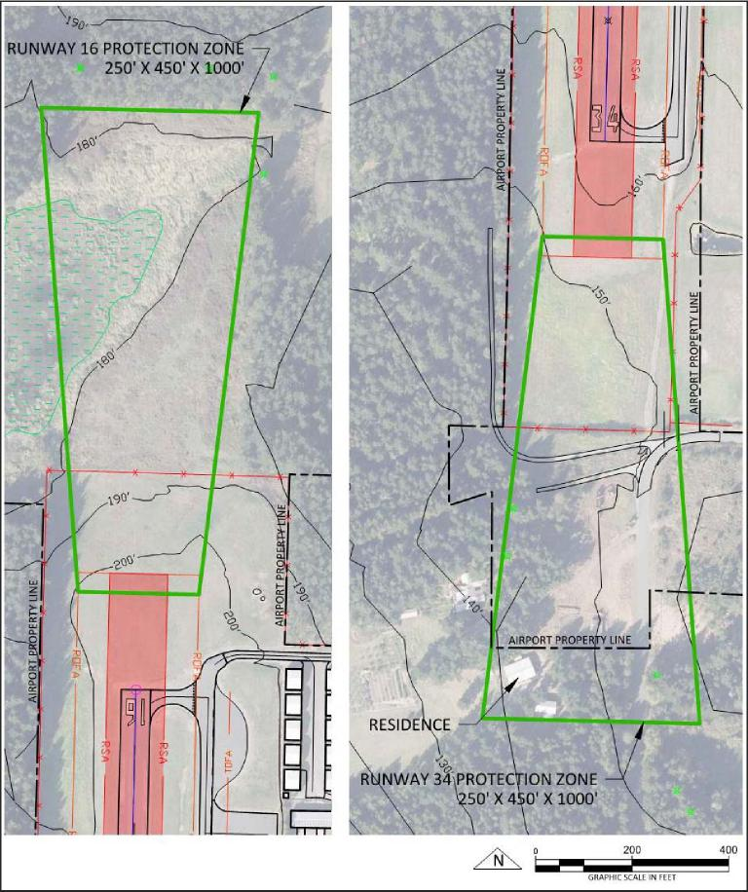
Runway End Siting
Criteria contained in AC 150/5300-13A provide guidance for the proper siting of runway ends and thresholds. The criteria are in the form of evaluation surfaces that are typically trapezoidal shaped and extend away from the runway along the centerline at a specific slope, expressed in horizontal feet by vertical feet (e.g., a 20:1 slope rises one unit vertically for every 20 units horizontally). Like RPZs, the specific size, slope, and starting point of the surfaces depend on the visibility minimums and aircraft type associated with the runway end.
Lopez Island Airport 4-10
Master Plan Update
December 2018

Obstructions are one of the most significant issues facing the Port because of the many trees located within the approach areas to both runway ends. In the past year, the Port has been in the process of removing trees on airport-owned property.
Threshold Siting Analysis
Thresholds are located to provide proper clearance over obstacles for landing aircraft on approach to a runway end. When an object beyond an airport owner’s ability to remove, relocate, or lower obstructs the airspace required for aircraft to land at the beginning of the runway for takeoff, the landing threshold may require a location other than the end of pavement (i.e., a displaced threshold). The existing criteria for Lopez Island Airport and the requirements for an airport designed to accommodate small aircraft only with approach speeds greater than 50 knots and having only visual approaches are presented in Table 4-7.
Table 4-7. Threshold Siting Surfaces, In Feet
Threshold Siting Surface | Distance  From Runway  End | Inner Width | Length | Outer  Width | Slope | Existing Obstructions
Existing Dimensions
Runway 16 | 0 | 250 | 5,000 | 700 | 20:1 | Yes
Runway 34 | 0 | 250 | 5,000 | 700 | 20:1 | Yes
Standard Threshold Siting Surface Dimensions Applicable to Lopez Island Airport
Small aircraft only with approach speeds > 50 knots, visual approach | 0 | 250 | 5,000 | 700 | 20:1
Source: FAA AC 150/5300-13A, Change 1, Airport Design.
There are a number of trees that penetrate the threshold siting surfaces for both runway ends, as illustrated in Exhibits 4-5 and 4-6. The Port of Lopez owns most of the property where the trees are located within the approach areas, but several trees are located beyond Port-owned property. The Port is currently scheduled to remove all the trees within the north portion of airport property, as identified on Exhibit 4-4. It is recommended that the Port continue the process of trimming or removing the trees on airport property, and explore options to attain the rights to remove or trim the trees beyond airport property.

Lopez Island Airport 4-11
Master Plan Update
December 2018

Exhibit 4-5. Runway 16 Threshold Siting Surface, Plan and Profile
i --
. . . . , •----.
, I  , _{i} |  |  |  |  |  |  |  |  |  | criFTEiSHOLD SITING SURFACE  , i  ; , 'TOE 2 (SLOPE 20:,1) • I |  |  |  |  |  |  |  |  |  |  |  |  |  |  |  |  |  |  |  |  |  | SCHEDULED TREE ,:REMOVAL AREA |  |  |  |  |  |  |  |  |  |  |  |  |  | . _  ....-
I 1 i )
I I |  |  |  |  |  |  |  |  |  |  |  |  |  |  |  |  |  |  |  |  |  |  |  |  |  |  |  |  |  |  |  | .
i . |  |  |  |  |  |  |  |  |  |  |  |  |  |  |  |  |  |  |  |  |  |  |  |  |  |  |  |  |  |  |  |  |  |  |  |  |  |  |  |  |  |  |  |  |  | /
 |  |  |  |  |  |  |  |  |  |  |  |  |  |  |  |  |  |  |  |  |  |  |  |  |  |  |  |  |  |  |  |  |  | .
• |  |  |  |  |  |  | i I |  |  |  |  |  |  |  |  |  |  |  |  |  |  |  |  |  |  |  |  |  |  |  |  | / |  | ..  .._{r}.:.:_‘ ........___ ••  ...--- |  |  |  |  |  |  |  |  |  |  |  | - . '..Q.0 |  |  |  | _7------..1
 |  |  |  |  |  |  | j , ^{i} |  |  |  |  |  |  |  |  |  |  |  |  |  |  |  |  |  |  |  |  |  |  |  |  |  |  | - --.:-.-_,  I  , •• ..,...,
„....,.......................... |  |  |  |  |  |  | , |  |  |  |  |  |  |  |  |  |  |  |  |  | REES,. |  |  |  |  |  |  |  |  |  |  | ,  : |  |  |  |  |  |  | , |  |  |  |  |  |  | .
,_{f}
I
 |  |  |  |  |  |  |  |  |  |  |  |  |  |  |  |  |  |  |  |  |  |  |  |  |  |  |  |  |  |  |  |  |  |  |  |  |  |  |  |  |  |  |  |  |  | c.
5010'.480' 46U0' |  |  |  | 4, 0' 42 |  |  | 0' 40b0•.., 38 Q' 36b0'' 3'4 ' 32 0',. 30 0' 28 ' ' 2 |  |  |  |  |  |  |  |  |  |  |  |  |  | 0' 22 0' 20b0" |  |  |  |  |  | 18 |  |  |  |  | !,- |  | 14 0' 1 |  |  |  |  | 0' 1000' 600' |  |  |  | ,
 |  |  |  | _
 |  |  |  | 16. II  ,., |  |  |  |  |  |  |  |  |  |  |  |  |  | I II '.. •:; •—  -<:., |  |  | • |  |  |  |  |  | .. |  |  |  |  | — |  |  |  |  |  |  | ----- |  |  |  |  |  |  |  |  | , /  ;_, ...•
---.......----- .......
z :—.••••,
/ • ,.•••-  - ( ''•  ' RUNWAY⁻PROTECTIONZONE—• W.16 THRESHOLD  ,_,.„. • 1 \`:L.N. ;  250' )(450¹X:1000-¹-⁻ ,, _ |  |  |  |  |  |  |  |  |  |  |  |  |  |  |  |  |  |  |  |  |  |  |  |  |  |  |  |  |  |  |  |  |  |  |  |  |  |  |  |  |  |  |  |  |  | ..----  . .—•
_ ---
0 600 1200
RUNWAY 16
52)0' | 50)0' | 48)0' |  |  | 4630'  GRAPHIC SCALE  44p0' 4200' 40)0' |  |  |  |  |  | 3830' | IN FEET  36)0' | 34)0' | 32)0' |  | 3030'  28)0' |  |  |  | 2690'  24)0' |  | 2200' |  |  | 20)0' |  |  |  |  |  | 1870'  16)0' |  |  |  |  |  | 14)0'  12)0' |  |  | 110' 8C0' |  |  |  | 6(0' | 4C0' |  |  |  | 2C0' |  |  | C'  -2)0'
480'  460 |  |  |  |  |  |  |  |  |  |  |  |  |  |  |  |  |  |  |  |  |  |  |  |  |  |  |  |  |  |  |  |  |  |  |  |  |  |  |  |  |  |  |  | , |  |  |  |  |  |  |  |  | 480'  460'
 |  | —,----..,.................. |  |  |  |  |  |  |  |  |  |  |  |  |  |  |  |  |  |  |  |  |  |  | THRESHCLD |  |  |  |  |  | SITING |  |  |  | SURFACE |  |  |  |  | '''YPE |  | 2
440'  420' |  |  |  |  |  |  |  |  |  |  |  |  |  |  |  |  |  |  |  |  |  | (SLOPE |  |  |  |  |  | 20:1) |  |  |  |  |  |  |  |  |  |  |  |  |  |  |  |  |  |  |  |  |  |  |  |  | 440'  420'
 |  |  |  |  | ⁵.00z
400 |  |  |  |  |  |  |  |  |  |  |  |  |  |  |  |  |  |  |  |  |  |  |  |  |  |  |  |  |  |  |  |  |  |  |  |  |  |  |  |  |  |  |  |  |  |  |  |  |  |  |  |  | 400'
 |  |  |  |  |  |  |  |  |  |  |  |  |  |  |  |  |  |  |  |  |  |  |  |  |  |  |  |  |  |  | TREES |  |  |  |  |  | WITHIN |  |  |  |  | THRESHOLD |  |  |  |  |  |  |  |  |  |  | 380'
360' |  |  |  |  |  |  |  |  |  |  |  |  |  |  |  | ZOO' |  |  |  |  |  |  |  |  |  |  |  | _{ve,/}/— |  |  | SITING |  |  |  |  |  | -SURFACE |  |  |  |  |  |  |  |  |  |  |  |  |  |  |  | 360'  340'
340'
320 |  |  |  |  |  |  |  |  |  |  |  |  |  |  |  |  |  |  |  |  |  |  |  |  |  |  |  | ' |  | '' |  |  |  |  | _{ptIL} |  |  |  |  |  |  |  |  |  |  |  |  |  |  |  |  |  | 320'
300 |  |  |  |  |  |  |  |  |  |  |  |  |  |  |  |  |  |  |  |  |  |  |  |  |  |  |  |  |  |  |  |  |  |  |  | ILIIK__{I} |  |  |  |  |  | RW 16 |  |  | THIESHOLD |  |  |  |  |  |  |  | 300'  80'
280' |  |  |  |  |  |  |  |  |  |  |  |  |  |  |  |  |  |  |  |  |  |  |  |  |  |  |  |  |  |  |  |  |  |  |  |  | • |  |  |  |  |  |  |  |  |  |  |  |  |  |  |  | '
260' |  |  |  |  |  |  |  |  |  |  |  |  |  |  |  |  |  |  |  |  |  |  |  |  |  |  |  |  |  |  |  |  |  |  |  |  | - |  |  |  |  |  |  |  |  |  |  |  |  |  |  |  | 260'
240' |  |  |  |  |  |  |  |  |  |  |  |  |  |  |  |  |  |  |  |  |  |  |  |  |  |  |  |  |  |  |  |  |  |  |  |  |  |  |  |  |  |  |  |  |  |  |  |  |  |  |  |  | 240'
220'  200 |  |  |  |  |  |  |  |  |  |  |  |  |  |  |  |  |  |  |  |  |  |  |  |  |  |  |  |  |  |  | ^{----".-----}7^{•-}"' |  |  |  |  |  |  |  |  |  |  |  |  |  |  |  | 500. |  |  |  |  |  | 220'
 |  |  |  |  |  |  |  |  |  |  |  |  |  |  |  |  |  |  |  |  |  |  |  |  |  |  |  |  |  |  |  |  |  |  |  |  |  |  |  |  |  |  |  |  |  |  |  |  |  |  |  |  | 200'
180 |  |  |  |  |  |  |  |  |  |  |  |  |  |  |  |  |  |  | -^{-r-} |  |  |  |  |  |  |  |  |  |  |  |  |  |  |  |  |  |  |  |  | - |  |  |  |  |  |  |  |  |  |  |  |  | 80'
160' |  |  |  |  |  |  |  |  |  |  |  |  |  |  |  |  |  |  |  |  |  |  |  |  |  |  |  |  |  |  |  |  |  |  |  |  |  |  |  |  |  |  |  |  |  |  |  |  |  |  |  |  | 60'
140' |  |  |  |  |  |  |  |  |  |  |  |  |  |  |  |  |  |  |  |  |  |  |  |  |  |  |  |  |  |  |  |  |  |  |  |  |  |  |  |  |  |  |  |  |  |  |  |  |  |  |  |  | 140' o  Lt.)  '-
120' |  |  |  |  |  |  |  |  |  |  |  |  |  |  |  |  |  |  |  |  |  |  |  |  |  |  |  |  |  |  |  |  |  |  |  |  |  |  |  |  |  |  |  |  |  |  |  |  |  |  |  |  | 120'
100  80 |  |  |  |  |  |  |  |  |  |  |  |  |  |  |  |  |  |  |  |  |  |  |  |  |  |  |  |  |  |  |  |  |  |  |  |  |  |  |  |  |  |  |  |  |  |  |  |  |  |  |  |  | 00'  —80'
60 |  |  |  |  |  |  |  |  |  |  |  |  |  |  |  |  |  |  |  |  |  |  |  |  |  |  |  |  |  |  |  |  |  |  |  |  |  |  |  |  |  |  |  |  |  |  |  |  |  |  |  |  | —60'
40 |  |  |  |  |  |  |  |  |  |  |  |  |  |  |  |  |  |  |  |  |  |  |  |  |  |  |  |  |  |  |  |  |  |  |  |  |  |  |  |  |  |  |  |  |  |  |  |  |  |  |  |  | —40'
 |  |  |  |  |  |  |  |  | _...--.-----"'-
20 |  |  |  |  | ,•.'- |  |  |  |  |  |  |  |  |  |  |  |  |  |  |  |  |  |  |  |  |  |  |  |  |  |  |  |  |  |  |  |  |  |  |  |  |  |  |  |  |  |  |  |  |  |  |  | —20'
0  20' |  |  |  |  |  |  |  |  |  |  |  |  |  |  |  |  |  |  |  |  |  |  |  |  |  |  |  |  |  |  |  |  |  |  |  |  |  |  |  |  |  |  |  |  |  |  |  |  |  |  |  |  | —0'  20' ⁰
5200' | 5030' 4850' 4630' |  |  |  | 4,60' 4230' |  |  |  | 40)0' |  |  | 3830'  36)0' |  | 3400' | 32)0' |  | 3030'  2870' |  |  | 2630'  2470' |  |  |  |  | 2230'  20)0' |  |  |  |  |  | 1830'  16 |  |  |  | 0' 1410' |  | 12)0' |  |  | 1000' 8C0' |  |  |  | 6C0' | 4C0' |  | 2(10' C' |  |  |  |  | -230'

Lopez Island Airport 4-12
Master Plan Update
December 2018

Exhibit 4⁻6. Runway 34 Threshold Siting Surface, Plan and Profile
.7⁷⁷⁻ |  |  |  |  |  |  |  |  |  |  |  |  |  |  |  |  |  |  |  |  |  |  |  |  |  |  |  |  |  |  |  |  |  |  |  |  |  |  |  | THRESHOLD SITING SURFACE TYPE 2 (sy_ap'E 20:1)
_{R}7 O |  |  |  |  |  |  |  |  |  |  |  |  |  | i
 |  |  |  |  |  |  |  |  |  |  |  |  |  |  |  |  |  |  |  | S (15')
 |  |  |  |  |  |  | e,)c
 |  |  |  |  |  |  |  |  |  |  |  |  |  |  |  | `3
120' |  |  |  |  |  |  |  |  |  |  |  |  |  |  |  |  |  |  |  |  |  |  |  |  |  |  |  |  |  |  |  |  |  |  |  |  |  |  |  |  | Ada\
34 THRESHOLD _/. \c3v⁻⁻⁻⁻-1—
RUNWAY PROTECTION ZONE
SfrX-45_0±X 1000'
\
TR TI TREES (TYP.) _
)
----⁻⁻⁻⁻⁻Th __-----------
0 400 800
RUN WAY 34 ,
-23C' |  | , air |  |  | 4 |  |  |  | 0' 6 |  | 0' 8 |  |  |  |  |  | 0' 1000' |  |  |  |  |  |  |  |  | 1200'  1400' |  |  |  | 1600' |  |  |  | 18)0'  20)0' |  |  | 22)0' |  | 24)0'  50X0'440' |  |  | 26)C' |  | 28)0' |  | 30 |  | 0' 3230' |  | 3430' |  | 36(10' 38)0' |  |  |  |  |  | 40)0'  GRAPHIC SCALE  42p0' 44p0' 46)0' |  |  |  |  |  |  | IN FEET  4830'
 |  |  |  |  |  |  |  |  |  |  |  |  |  |  |  |  |  |  |  |  |  |  |  |  |  |  |  |  |  |  |  |  |  |  |  |  |  |  |  |  |  |  |  |  |  |  |  |  |  |  |  |  |  | _{f}l |  |  |  | _{f}l
420'  400' |  |  |  |  |  |  |  |  |  |  |  |  |  |  |  |  |  |  |  |  | THRESHOLD |  |  |  |  | SITING |  |  |  |  |  | SURFACE |  |  |  |  |  |  |  |  |  |  |  |  |  |  |  |  |  |  |  |  |  |  |  |  |  |  |  |  |  |  | _.-------- |  |  | __,-------
380' |  |  |  |  |  |  |  |  |  |  |  |  |  |  |  |  |  |  |  |  |  |  |  |  |  | TYPE |  |  |  | 2 (SLOPE |  | 20:1)
360'
340'
320'
 | TR | =ES WITHIN |  |  |  |  |  |  | THRESHOLD |  |  |  |  |  |  |  |  |  |  |  |  |  |  |  |  |  |  |  |  |  |  |  |  |  |  |  |  |  |  |  |  |  |  |  |  | ..---------------
300'  280 ' |  |  |  |  | SITING |  |  |  | SUR |  | ACE
260'  240' |  | ^{RW} |  |  |  |  |  |  | ^{34 THRES} |  | ^{OLD} |  |  |  |  |  |  |  |  |  |  |  |  |  |  |  |  |  |  |  |  | ....._____-•--
 |  |  |  |  |  |  |  |  |  |  |  |  |  |  |  |  |  |  | j),_----(° |  |  |  |  |  |  |  |  |  |  |  |  |  |  |  |  |  |  |  |  |  |  | ^{N}220'
200' |  |  |  |  | ROADS |  |  |  | (15')
180'
160'
 |  |  |  |  |  |  |  |  |  |  |  |  |  |  |  |  |  |  |  |  |  |  |  |  |  |  |  |  |  | _
140 |  |  |  |  |  |  |  |  |  |  |  |  |  |  |  |  |  |  |  |  |  |  |  |  |  |  |  |  |  |  |  |  |  |  |  |  | -,---- |  | ----------________ |  |  |  |  |  |  |  |  |  |  |  |  |  |  |  |  |  |  |  |  |  |  |  |  |  |  |  | 8  .-
120' |  |  |  |  |  |  |  |  |  |  |  |  |  |  |  |  |  |  |  |  |  |  |  |  |  |  |  |  |  |  |  |  |  |  |  |  |  |  |  |  |  |  |  |  |  |  |  |  |  | -------__
100' |  |  |  |  |  |  |  |  |  |  |  |  |  |  |  |  |  |  |  |  |  |  |  |  |  |  |  |  |  |  |  |  |  |  |  |  |  |  |  |  |  |  |  |  |  |  |  |  |  |  |  |  |  | _
80'
60
40'
-23C' |  | 2 |  |  | 0' 4 |  |  |  | 0' 6,0' |  | °CO' |  |  |  |  |  | 1000' |  |  |  |  |  |  |  |  | 1200'  14 |  |  |  | 0' 16 |  | 0' 1830' |  | 20)0' |  |  | 2200' |  | 2400' |  |  | 263C' |  | 2830' |  | 30 |  | 0' 3230' |  | 3430' |  | 3630' 3830' |  |  |  | 40)0' 4230' |  |  |  |  | 4430' 4630' |  |  |  | 4830' | 5030' | o

Lopez Island Airport 4-13
Master Plan Update
December 2018

Runway Marking, Lighting, and Signage
Runway 16/34 is provided with basic visual markings and is equipped with holding position lines at all taxiway intersections conforming to standards for visual approaches provided in AC 150/5300-13A, Change 1 and AC 150/5340-1L, Standards for Airport Markings. The airport’s 5010 Form indicates they are in good condition. The runway is equipped with Medium Intensity Runway Lights (MIRLs), two-light Precision Approach Path Indicator (PAPI), and Runway End Identifier Lights (REILs) at each runway end. According to AC 150/5300-13A, Lopez Island Airport is equipped with satisfactory marking, lighting, and signage to meet the current and forecast aircraft fleet requirements. However, the existing MIRL is dated and the Port plans to replace the system in the near future.
Taxiway System
Taxiways facilitate aircraft movement between the various functional landside areas on an airport and the runway system. Taxilanes are designed for low speed and precise taxiing of aircraft that are usually, but not always, located outside the movement area, providing access from taxiways (usually an apron taxiway) to aircraft parking positions or hangar areas. Taxiways and taxilanes are designed for “cockpit over centerline” taxiing with sufficient pavement width to allow for a certain amount of wander. Potential runway incursions should be kept to a minimum by proper taxiway design criteria contained in AC 150/5300-13A. Taxiway and taxilane clearance requirements are based on wingtip clearance, a function of aircraft wingspan, and are determined by the Airplane Design Group (ADG) of the design aircraft, which at Lopez is the “I” in the B-I critical aircraft design group. Taxiway and taxilane pavement design standards are related to the Taxiway Design Group (TDG), which is based on the overall Main Gear Width (MGW) and the Cockpit to Main Gear (CMG) distance of the design aircraft. The existing and forecast aircraft fleet indicate that ADG I and TDG 1A are appropriate for the design of the taxiway system at Lopez Island Airport.
The airport is equipped with a full parallel taxiway and five taxiway connectors providing access between the runway and parallel taxiway. Taxiway widths range from 25 to 30 feet. Table 4-8 provides the existing taxiway conditions and appropriate taxiway design standards.

Lopez Island Airport 4-14
Master Plan Update
December 2018

Table 4-8. Taxiway Design Standards, In Feet
Design Standard | Existing  Dimension | Design Standard Dimension
Design Standard Based on ADG |  | ADG I
Taxiway Safety Area | 49 | 49
Taxiway Object Free Area | 87.3 | 89
Taxilane Object Free Area | 50, 79 | 79
Taxiway Centerline to:
Parallel Taxiway/Taxilane Centerline | NA | 70
Fixed or Movable Object | 42.8 | 44.5
Taxilane Centerline to:
Parallel Taxilane Centerline | NA | 64
Fixed or Movable Object | 40 | 39.5
Design Standard Based on TDG |  | TDG 1A
Parallel Taxiway Width | 25 | 25
Mid-field Taxiway Widths | 30 | 25
Source: FAA AC 150/5300-13A, Change 1, Airport Design.
Taxiway Standards Analysis. Applying the appropriate TDG and ADG design standards to the existing taxiway conditions indicates that Lopez Island Airport meets or exceeds most of the taxiway design standards. The lone exception is the Taxiway Object Free Area (TOFA) associated with the parallel taxiway. A tree and the fence separating airport property from the golf course are located approximately 1.7 feet within the standard 44.5 feet from the taxiway centerline. This non-standard condition exists for a stretch of approximately 817 feet along the parallel taxiway. The Port should explore options for removing the tree and relocating the fence beyond the TOFA. Exhibit 4-7 graphically presents the deficiencies associated with the parallel taxiway.
It should be noted that the three mid-field taxiway connectors have widths of 30 feet, exceeding the TDG 1A design standard of 25 feet. FAA policies and guidelines indicate that funding for pavement maintenance and rehabilitation projects are generally limited to that required by the appropriate design standard. If the Port of Lopez decides to retain the extra taxiway connector widths, it must do so utilizing Port monies exclusively for the extra width.

Lopez Island Airport 4-15
Master Plan Update
December 2018

Exhibit 4-7. Parallel Taxiway Object Free Area Non-Standard Conditions
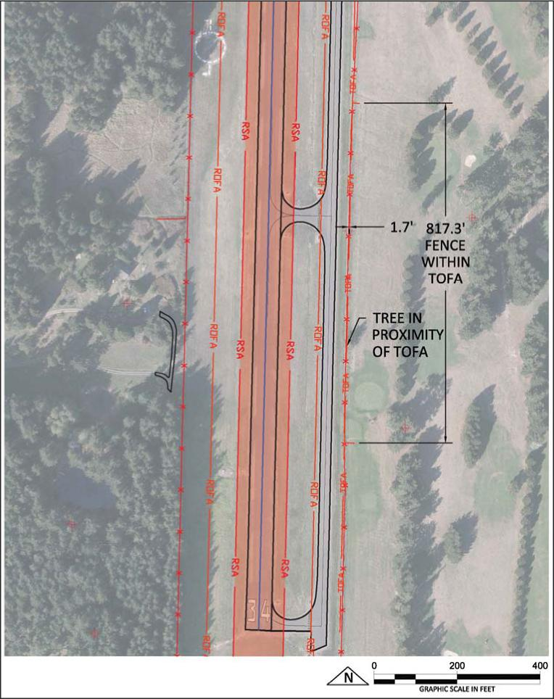
Taxilane Standards Analysis. Applying the appropriate criteria to the existing taxilanes on the airport indicates that the taxilanes providing access to the private and Port-owned hangars, and between the hangars, have Object Free Area widths of approximately 50 feet, 29 feet less than the required TDG 1A design standard of 79 feet. The Port should amend their hangar leases to provide notice of the existing limited distance between the hangars and have lessees sign hold harmless agreements for any and all damages. When age and condition of the hangars warrant replacement, it is recommended that all FAA setback standards be incorporated into the design of future hangars.
Lopez Island Airport 4-16
Master Plan Update
December 2018

The taxilane located at the north end of the parallel taxiway providing access to the private hangars exceeds the 2.0% FAA standard grade for Aircraft Approach Categories A and B. The overall grade is approximately 6.1%, with parts of the existing grade exceeding 7.0%. The Port has a hold harmless agreement with aircraft owners basing their aircraft in the private hangars for any and all damages resulting from the steepness of the taxilane.
The airport incorporates standard taxiway signage that meets all FAA signage standards.
Instrument Approach Requirements
Runway 16/34 currently supports visual approaches only. Any improvements to the current approaches would use satellite based platforms rather than ground based systems. The FAA is currently implementing “NextGen” capabilities nationwide that will allow a higher level of efficiency between airports and provide innovative instrument approach and departures. It is not anticipated that Lopez Island Airport will be provided improved instrument approaches during the planning period.
Electronic Navigational Aids
The Port desires to install an Automated Weather Observing Station (AWOS) on the airport providing local weather reporting services to pilots. These stations require proper siting and ample land area to provide accurate data recording. Typically, stations are sited from 1,000 to 3,000 feet from the runway threshold and a minimum 500 feet from the runway centerline to a maximum of 1,000 feet. Wind sensors should be mounted at 30 to 33 feet above the average ground height within a radius of 500 feet. It is also desirable that all obstructions such as vegetation and buildings be at least 15 feet lower than the sensor within the 500-foot radius, and be no more than 10 feet above the sensor from 500 to 1,000 feet.
Landside Facility Requirements
Landside facilities are those airport facilities that support the airside facilities, but are not actually a part of the aircraft operating surfaces. They consist of such facilities as terminal buildings, hangars, aprons, access roads, and support facilities. At the Lopez Island Airport, landside facilities are the aircraft apron and hangars.
During the planning period, based aircraft are projected to increase from 24 to 32, with at least one multi-engine turboprop powered aircraft expected to be based at the airport. Currently, there are 16 tiedowns on the apron and 34 hangar spaces available for aircraft storage. Eight of the tiedowns are reserved for based aircraft (with two currently being used) and eight reserved for transient aircraft.
Table 4-9 summarizes the required space needs for aircraft storage throughout the planning period. As can be seen, there is more than adequate apron to meet the demand for based aircraft
Lopez Island Airport 4-17
Master Plan Update
December 2018

owners who may not desire to pay the cost for hangar spaces, but there may be a deficiency in tiedown spaces allocated for transient aircraft. However, the total number of tiedown spaces appears adequate to meet the demand if some of the reserved based aircraft spaces are reallocated for transient use.
The amount of hangar spaces available appears capable of accommodating the aircraft storage demand throughout the planning period.
Table 4-9. Aircraft Storage Requirements, 2015-2035
Aircraft Storage Type | 2015¹ | 2020 | 2025 | 2030 | 2035
Based Aircraft Apron
Number of Tiedowns | 8 | 1 | 1 | 1 | 2
Square Yards | 3,000 | 360 | 360 | 360 | 720
Transient Apron
Number of Tiedowns | 8 | 11 | 12 | 12 | 12
Square Yards | 3,800 | 4,600 | 4,800 | 4,800 | 4,800
Total Apron
Total Number of Tiedowns | 16 | 12 | 13 | 13 | 14
Total Square Yards | 7,200 | 5,840 | 6,240 | 6,240 | 6,240
T-hangar Spaces | 33 | 25 | 27 | 29 | 30
Source: Reid Middleton, Inc. and Mead & Hunt analysis using FAA AC 150/5300-13A, Change 1, Airport Design, and actual airport conditions.
Note: ¹Actual.
The Port has had ongoing discussions about the need for a fuel storage and dispensing system at the airport. At this time, it is not thought to be a necessary item to provide. However, this is a market-based business decision and each potential opportunity should be evaluated on its merits and compatibility with Port goals for the airport.
Summary of Facility Requirements
The facility requirements presented in this chapter form the basis of the development plan for the airport. Facility requirements are based upon current operations and future forecasts. Although many of the existing airport facilities are adequate, others will require improvement to accommodate the existing and future aviation demand safely and efficiently. Table 4-10 presents a summary of the facility requirements.
Lopez Island Airport 4-18
Master Plan Update
December 2018

Table 4-10. Summary of Facility Requirements, 2015-2035
Facility | 2015¹ | 2020 | 2025 | 2030 | 2035
Runway System
Runway Length and Width | 2,904’ X 60’ | Same | Same | Same | Same
RSA Length
Runway 16 | 200’ | 240’ | Same | Same | Same
Runway 24 | 200’ | 240’ | Same | Same | Same
Runway Protection Zones
Runway 16 | 250’ x 1000’ x 450’ | Same | Same | Same | Same
Runway 34 | 250’ x 1000’ x 450’ | Same | Same | Same | Same
Threshold Siting
Runway 16 | Obstructions | Remove | Same | Same | Same
Runway 34 | Obstructions | Remove | Same | Same | Same
Taxiway System
Taxiway Lights | Reflectors | Same | Same | Same | Same
Parallel Taxiway OFA |  |  | Remove Tree  and Relocate  Fence
Midfield Taxiway Connector Widths | 30’ | Same | Same | 25’ | Same
Electronic Navigational Aids
Weather Reporting System | None | AWOS | Same | Same | Same
Source: Reid Middleton, Inc. and Mead & Hunt.

Lopez Island Airport 4-19
Master Plan Update
December 2018

